**Assignment 4**

**Description:**

1. Assume that you have the following JavaScript code:

Code –

var someVar = "1";

var someObject = {

someVar: 2,

someMethod: function () {

var someVar = 3;

var _this = this;

setTimeout(function() {

var result = _this someVar + this someVar;

alert(result); //What is the value of result here?

if (result > 20) {

+result--;

} else {

+result++;

}

alert(result); //What is the value of result here?

}, 10);

}

};

someObject.someMethod();

let’s format a message containing a string and an integer

**Show the output.**

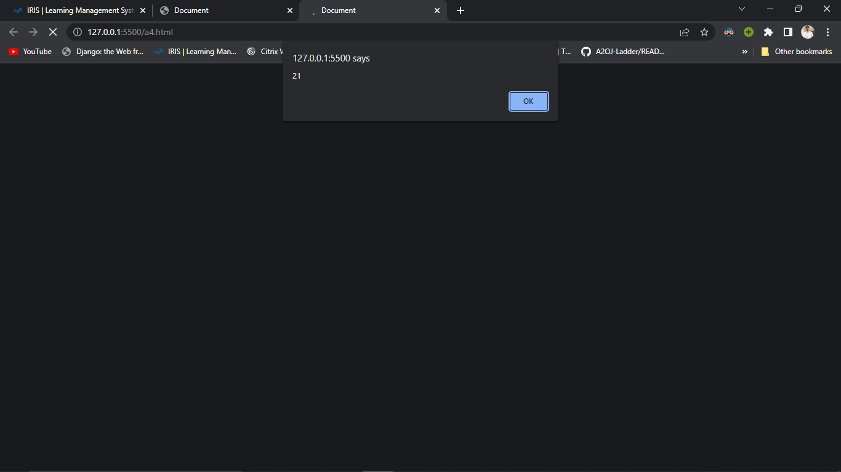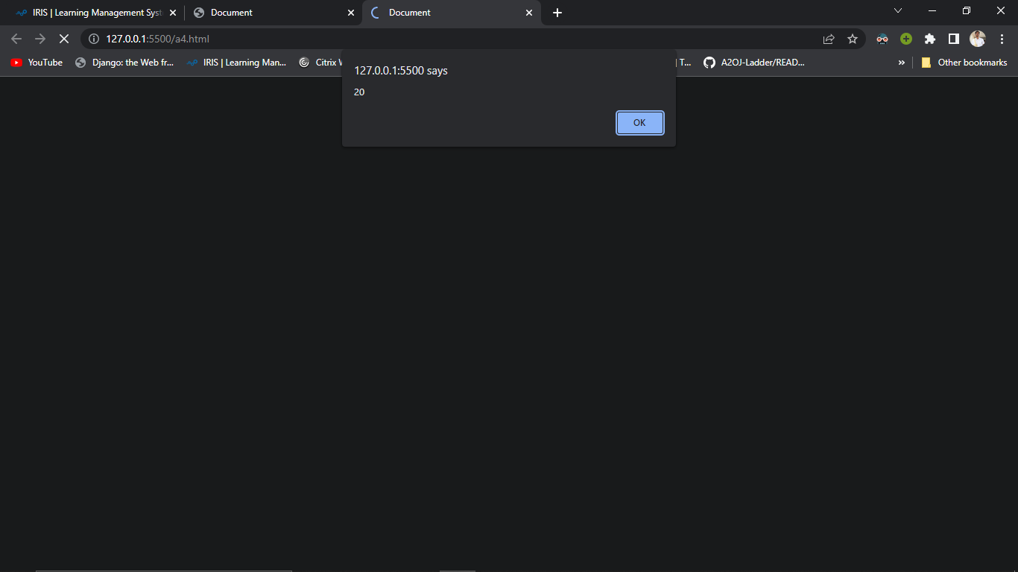

1. **Get the output from both alert(result) line?**

**YES**

1. **Using function() can we define various function within function with respect of javascript.**

**YES**

1. **What the output if decrement and increment operator are implemented with function.**

**21**

**20**

**Output:**

**Performance Outcomes:**

Upon successful completion of the assignment, the participant is well versed in

1. User are able to create function and use with within function and find the appropriate result.
2. Knowledge to maintain fix error and debugging with function code.
3. Able to know how can assign and get variable value using and **increment or decrement operator implemention.**